

Homework 6

Formal report

Logan | QMB 3200 | 9.29.2020

Table of Contents

List of Figures and Tables 2

Summary Statistics 2

Proportion Test 4

Ttest 7

Executive Summary 10

Summary statistics 10

Quantitative methods 10

Proportion Tests 10

T Tests 10

Conclusion 11

Appendix 12

# List of Figures and Tables

## Summary Statistics

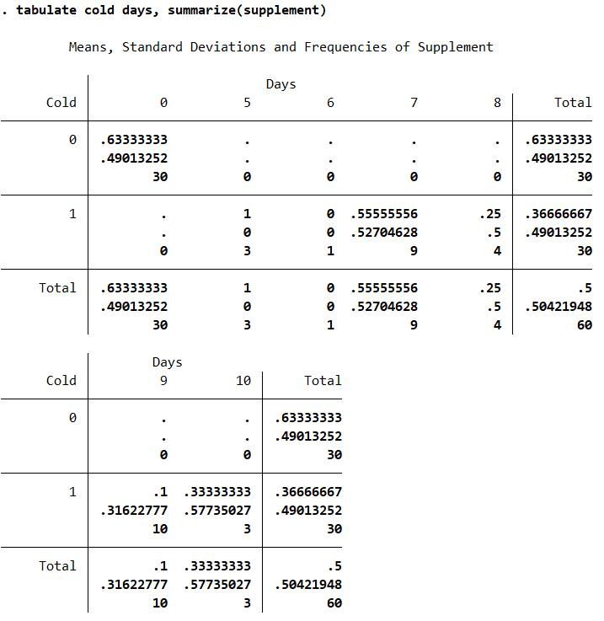SS Figure 1

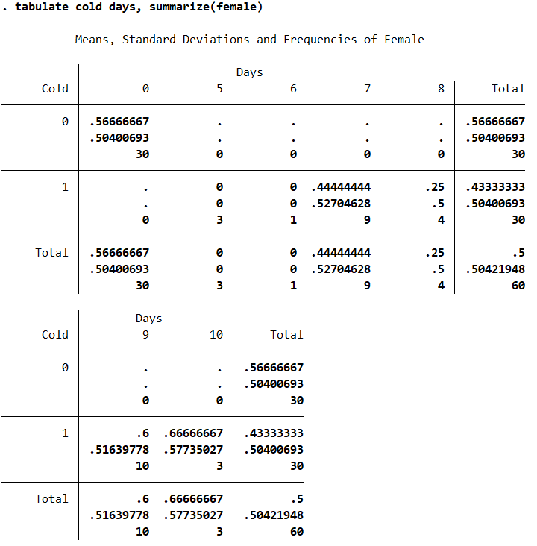

SS Figure 2

## Proportion Test

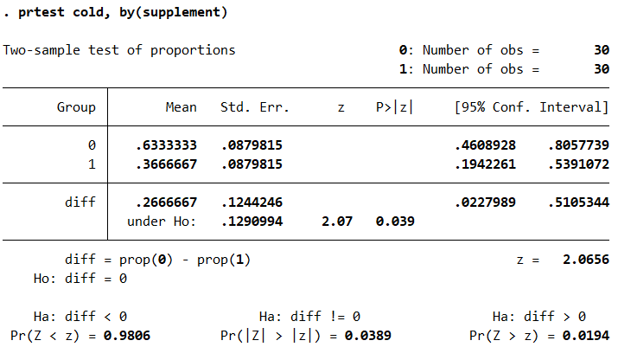

Figure 1

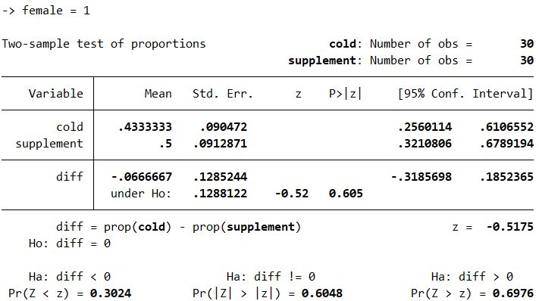

Figure 2

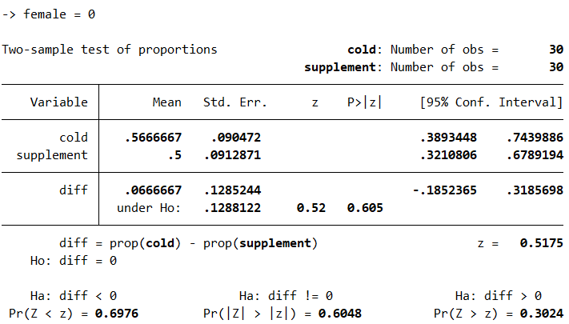

Figure 3

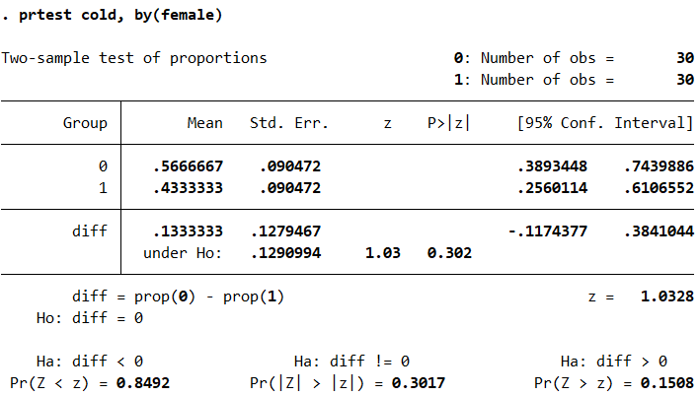

Figure 4

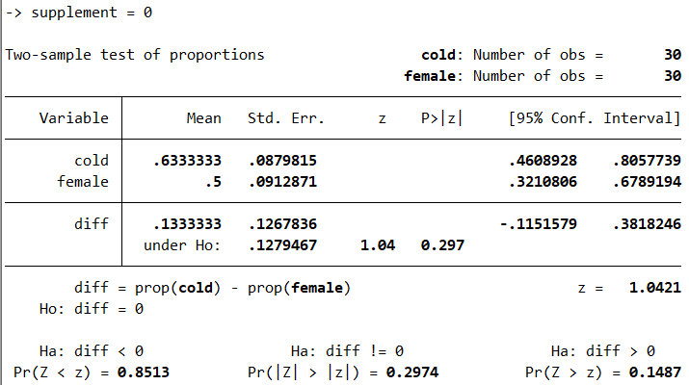

Figure 5

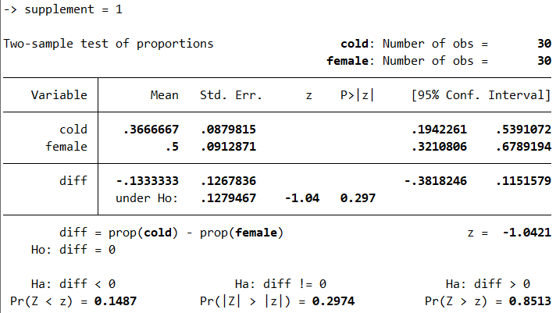

Figure 6

## Ttest

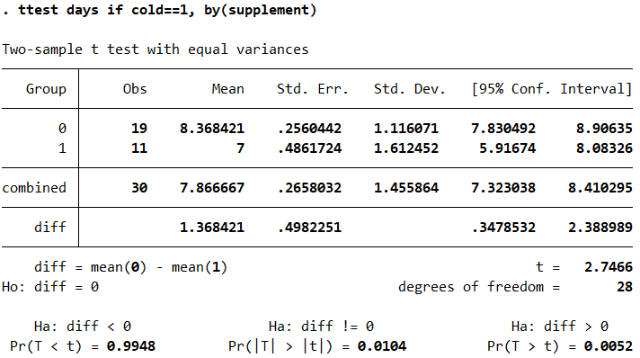

Figure 7

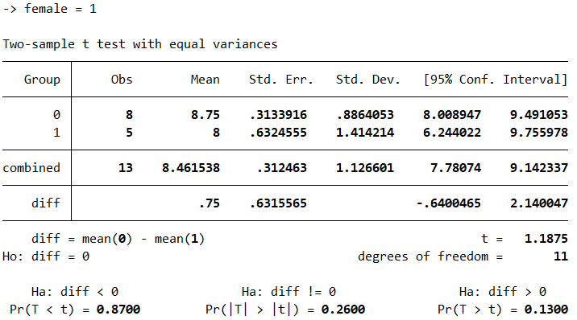

Figure 8

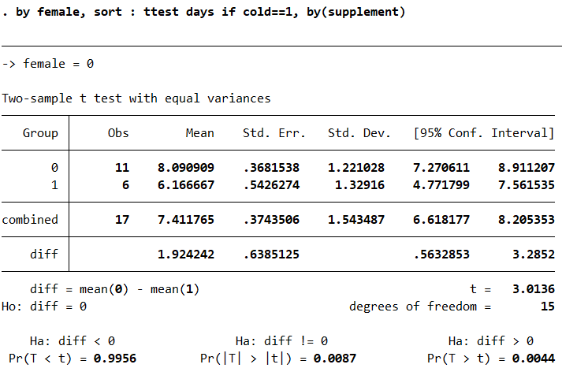

Figure 9

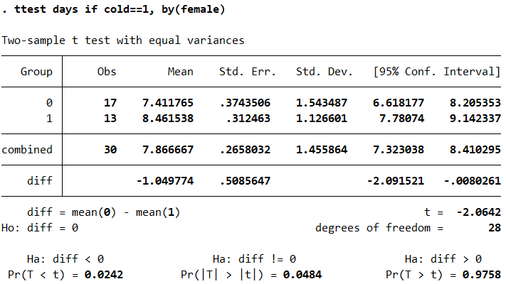

Figure 10

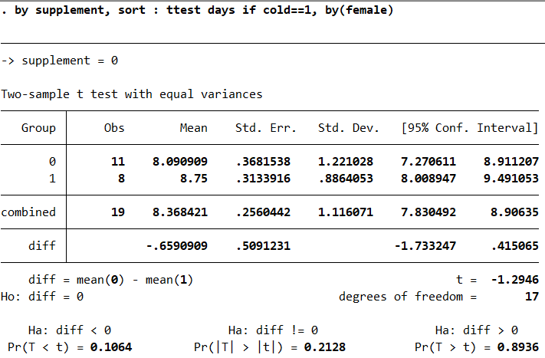

Figure 11

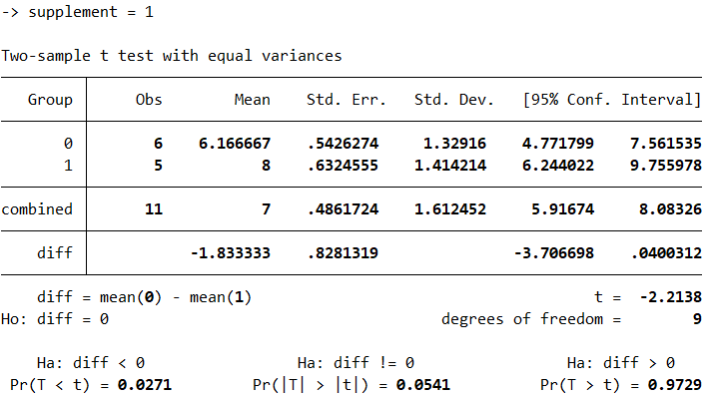

Figure 12

# Executive Summary

## Summary statistics

In figures SS Figure 1 and SS Figure 2, there is very little information to make a supported inference from. The information in these first two images is used as supporting evidence in following analysis.

## Quantitative methods

### Proportion Tests

In figure 1, the proportion of the population that had a cold was significantly lower in those that took the supplement, by nearly twenty-six percent. Only 36.67% of the participants who followed the supplement had the cold, whereas 63.33% of participants who did not take the supplement got the cold. An interesting piece of information is the 95% confidence interval for the participants who did take the supplement was 19.42% to 53.91%, a very large range and arguably unreliable. In figure 2 and 3, the female population had a marginally lower percentage of positive cold flu cases compared to men. This difference is insignificant. In figure 4, the difference between the males and females getting the cold is only 13.33%, hardly evidence to disprove causation. In figures 5 and 6, 63% of participants who did not have the supplement had a 63% chance of getting the cold whereas, only 37% of participants were likely to get the cold if they had the supplement.

### T Tests

In figure 7, the average number of days of a person without a supplement was 8.37. For a person with the supplement, the average number of days dropped to 7 days exactly. In figures 8 and 9, when looking specifically at men and women, the average number of days with the cold after starting the supplement dropped from 8.75 to 8 and from 8 to 6 in men. Therefore, concluding that the supplement reduced the average number of days of having to deal the cold more significantly in men than in women. In figure 10, for the participants that had the cold, men would have symptoms for an entire day longer, on average, than women, regardless of the supplements. In figures 11 and 12, gender made little to no difference on the overall effectiveness.

# Conclusion

In conclusion, the supplement seems to benefit men more than women. Though, the supplement still benefits women significantly. The biggest positive of the supplement was the reduction in the number of days of the cold symptoms in men mostly but also women. The biggest negative was the overall difference in number of days dealing with cold symptoms by gender, regardless of the supplement which concluded that there is very little evidence to prove that simply being male or females does not determine how long someone will have to deal with cold symptoms.

# Appendix

cd "C:\Users\lmm56\Documents\School\Poly 20 - 21\QMB 3200\Homework Submissions\Assignment 6"

log using "homework 6", replace

import delimited "Assignment 6 Supplement.csv"

tabulate female supplement, summarize(cold)

tabulate female supplement, summarize(days)

prtest cold, by(supplement)

by female, sort : prtest cold == supplement

prtest cold, by(female)

by supplement, sort : prtest cold == female

ttest days if cold==1, by(supplement)

by female, sort : ttest days if cold==1, by(supplement)

ttest days if cold==1, by(female)

by supplement, sort : ttest days if cold==1, by(female)

log close

clear